**HomeWork 4**

[AWS-LB, AS](https://cs.wmich.edu/gupta/teaching/cs6030/6030cloudFall2019web/hw4.html)

Launch EC2 instance

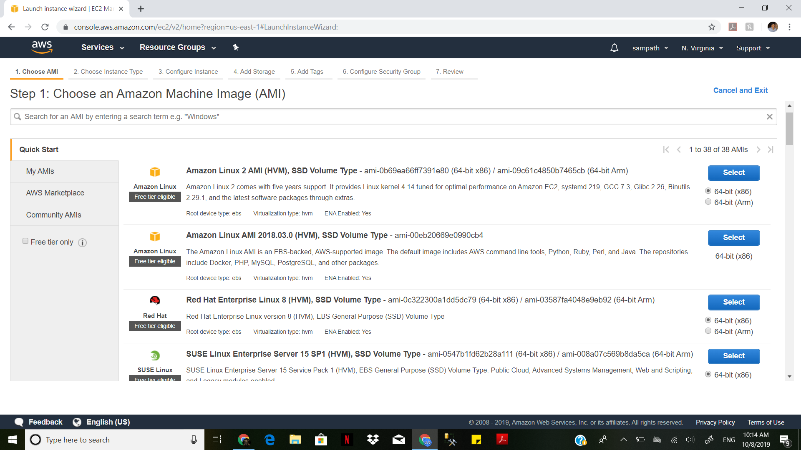

Give the user to access Web-page

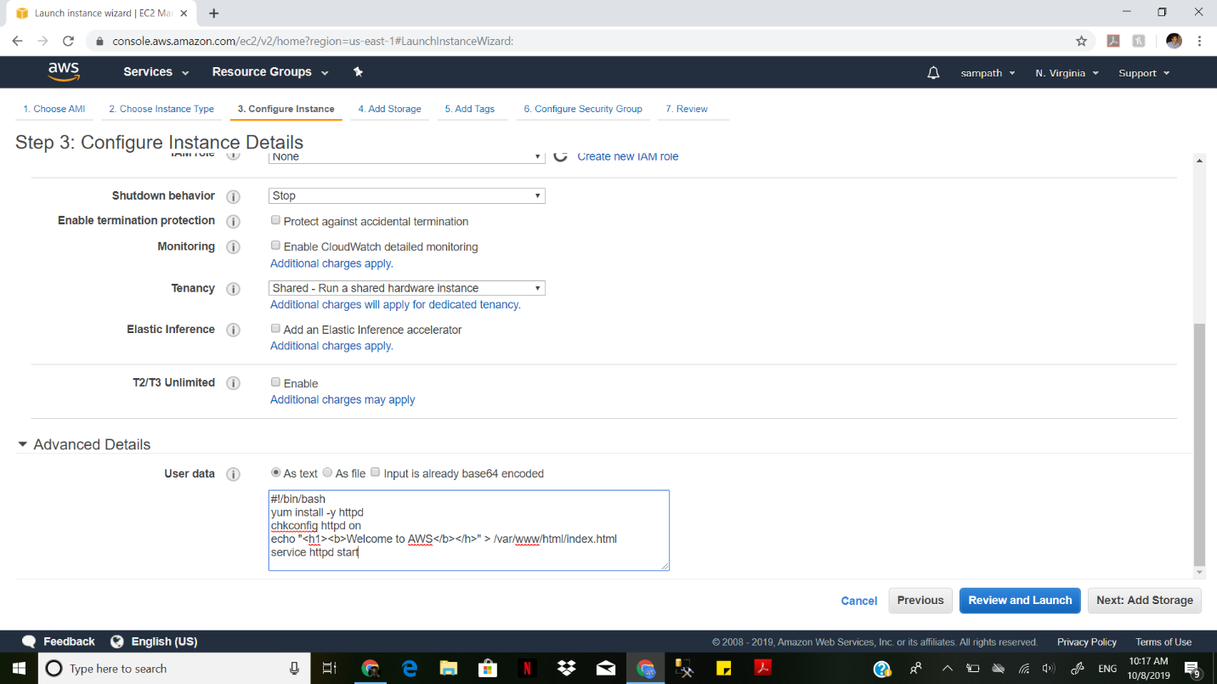

Add a tag to the instance

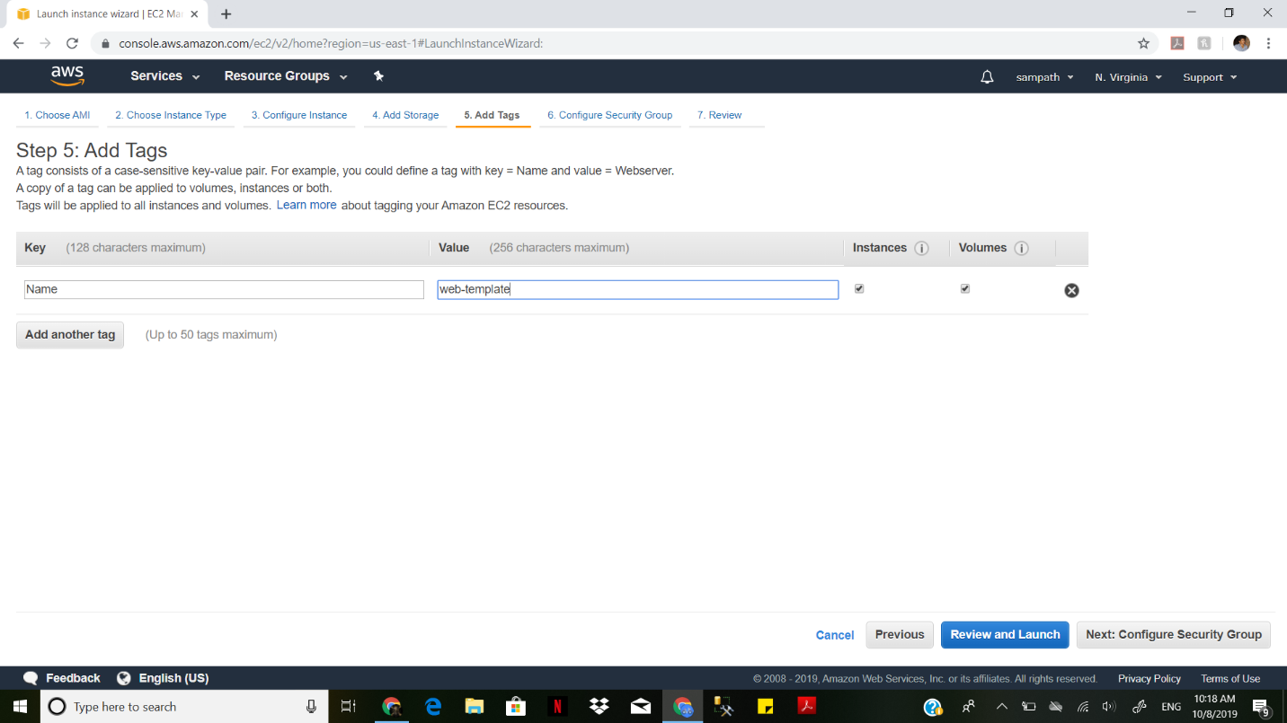

Choose a Key pair for instance

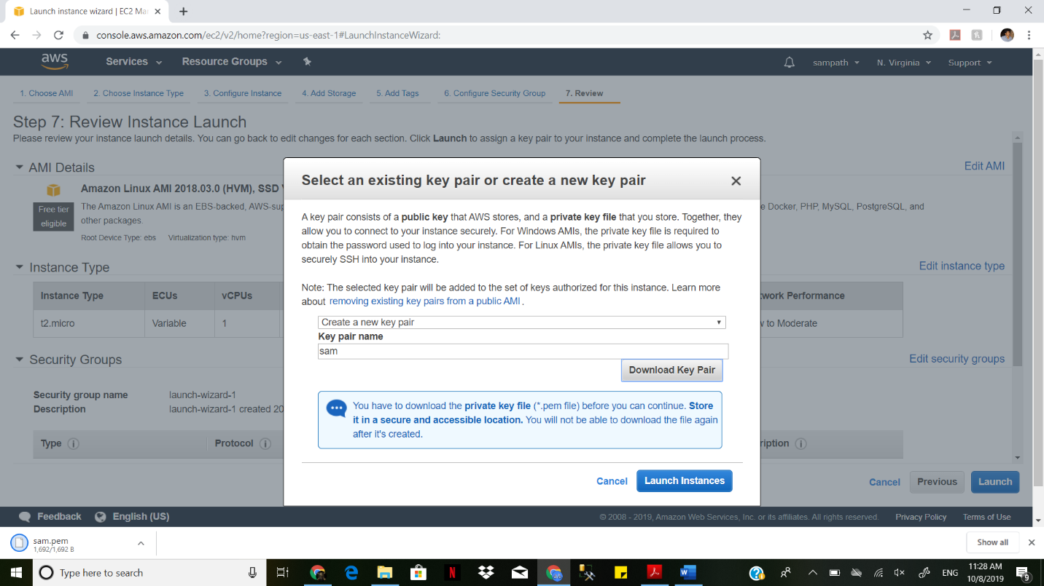

Launching the instance

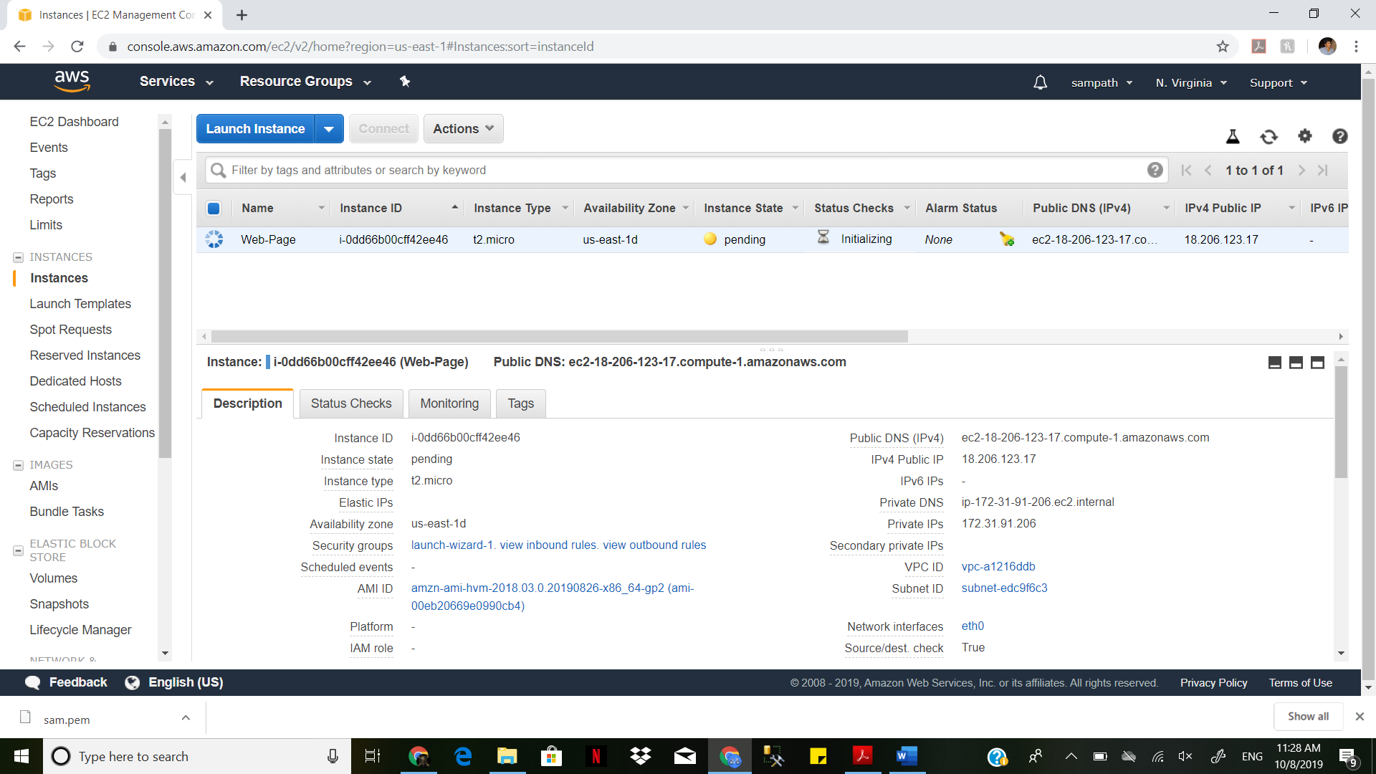

Copying the public IPV4 and accessing the web page created in instance.

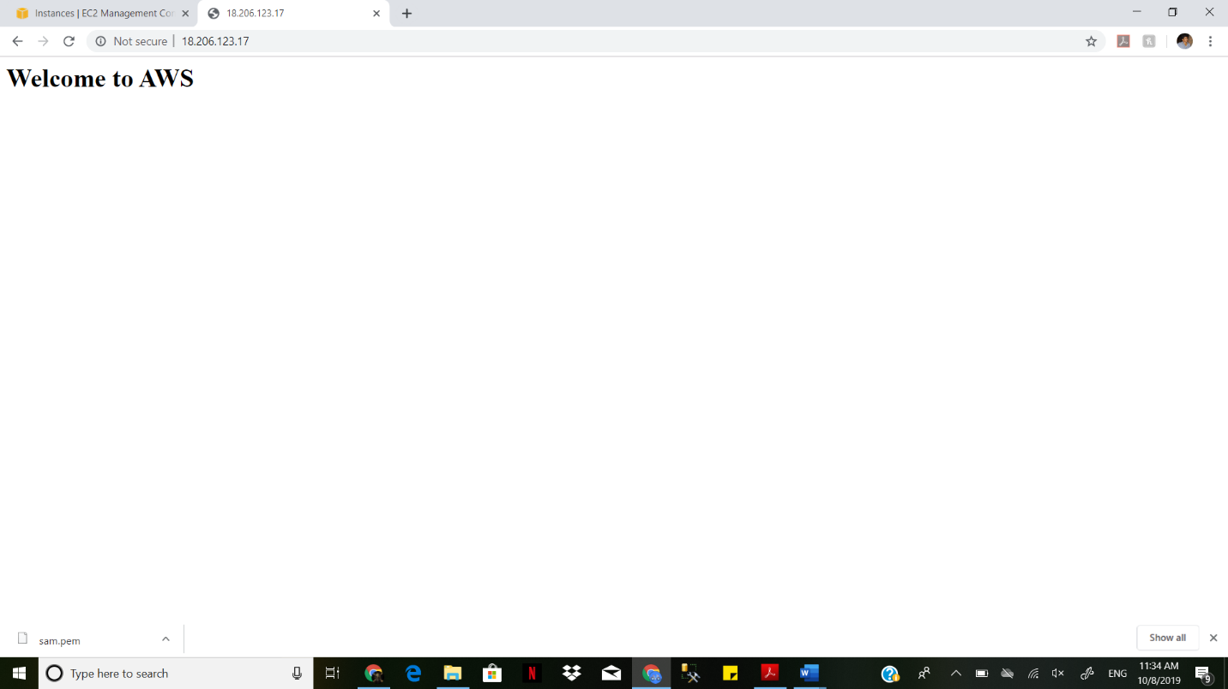

Creating image from instance

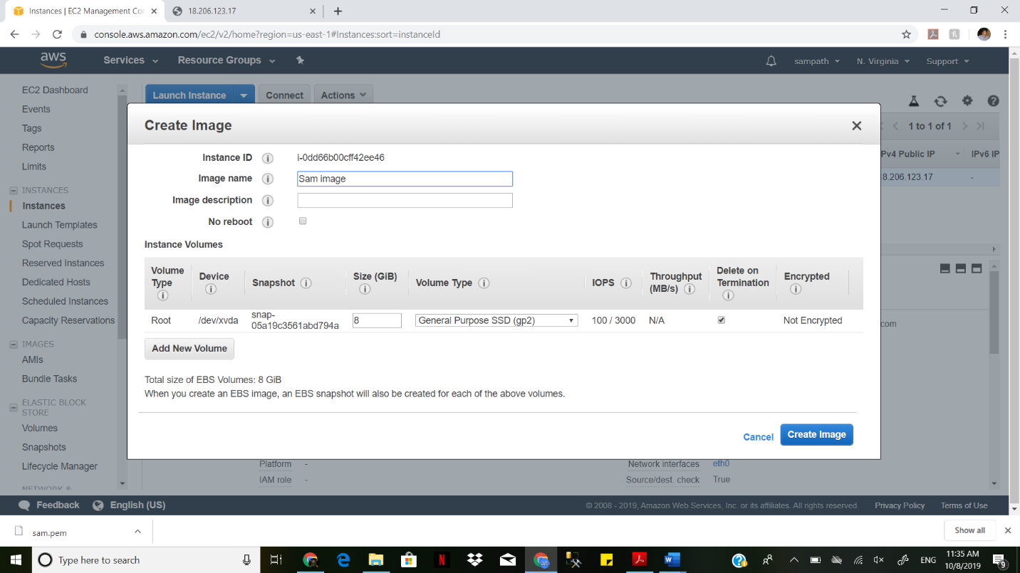

Launching the image

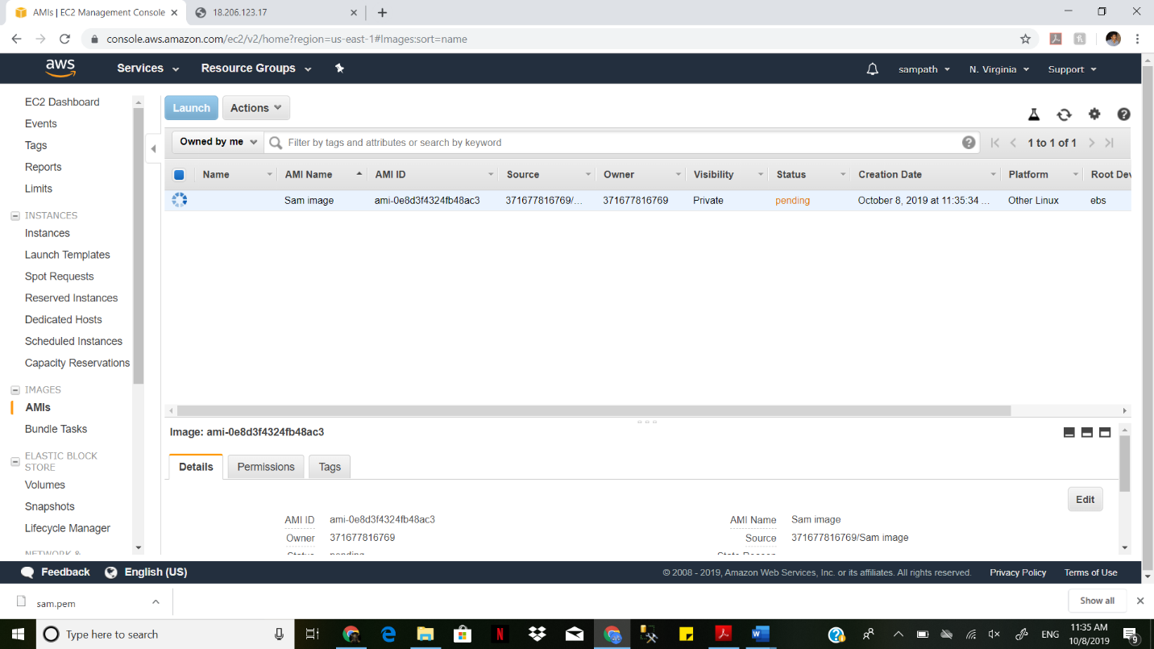

Deleting the Instance and security Group which we created previously.

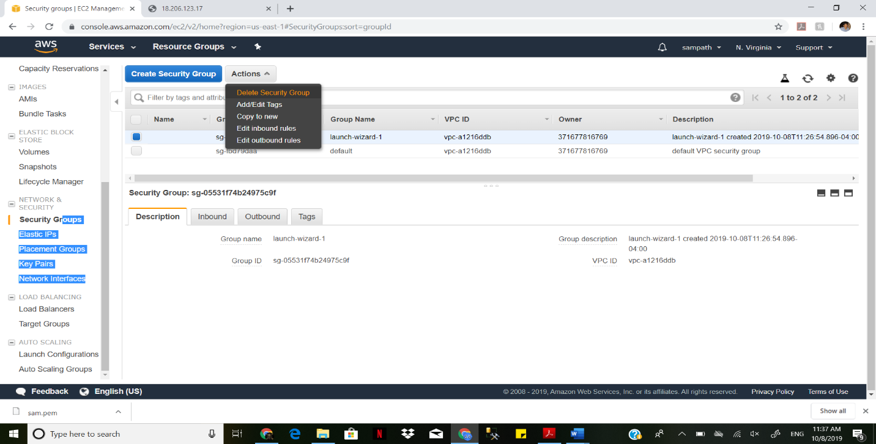

Creating a Load Balancer

Configure the security

Add name to Load Balancer

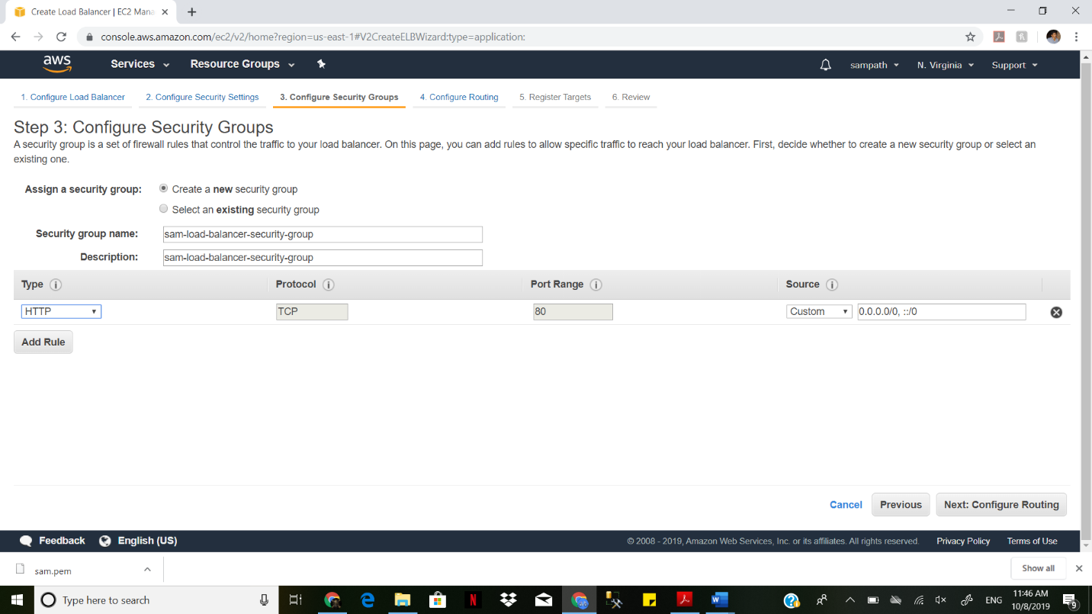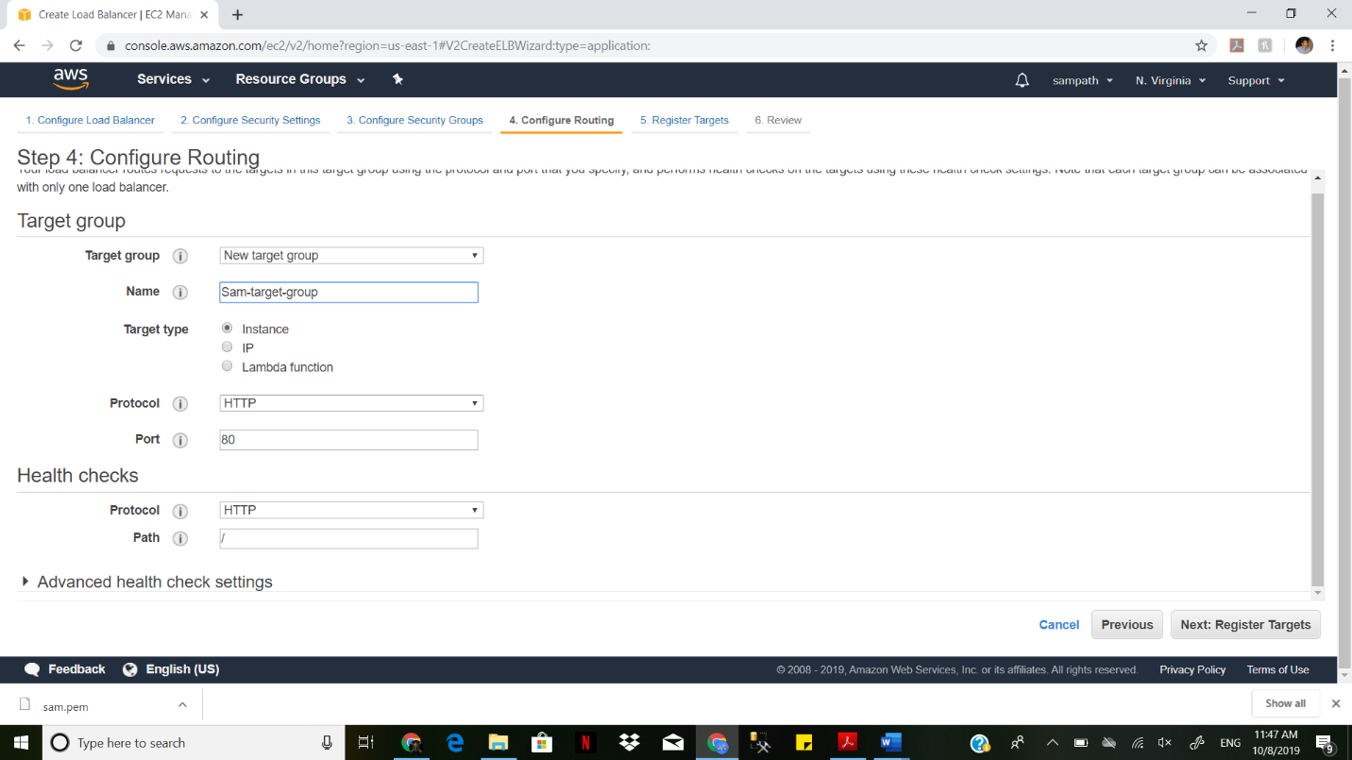Adding Target group to load balancer

Create Load Balancer

We should wait for few minutes to get status available

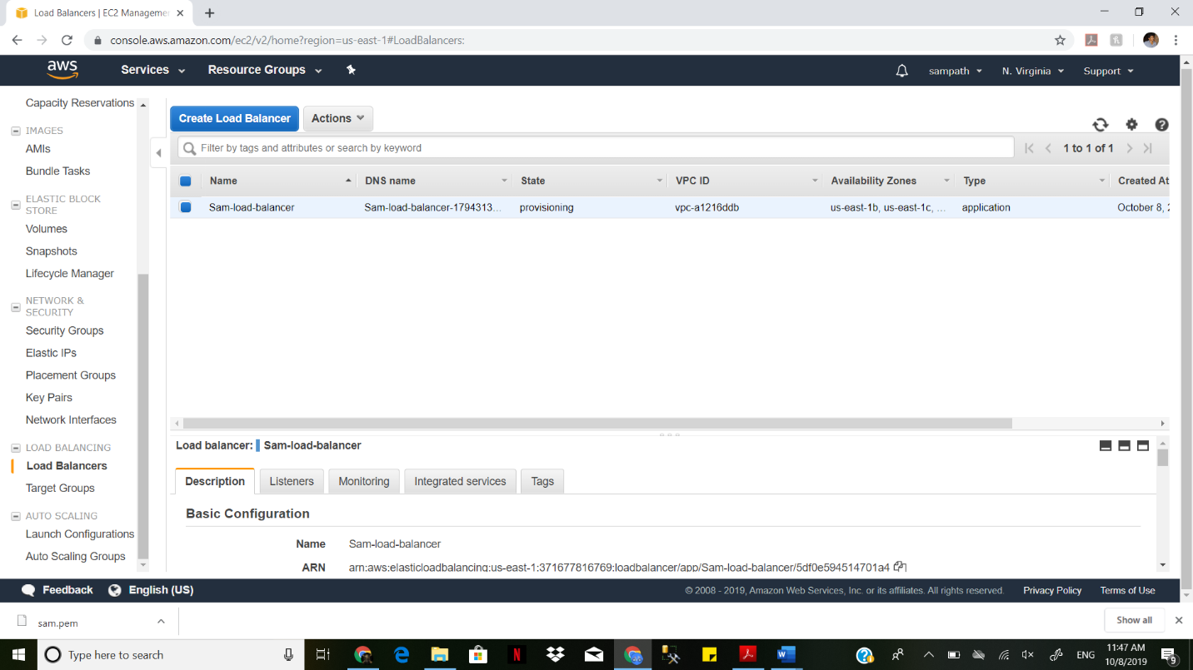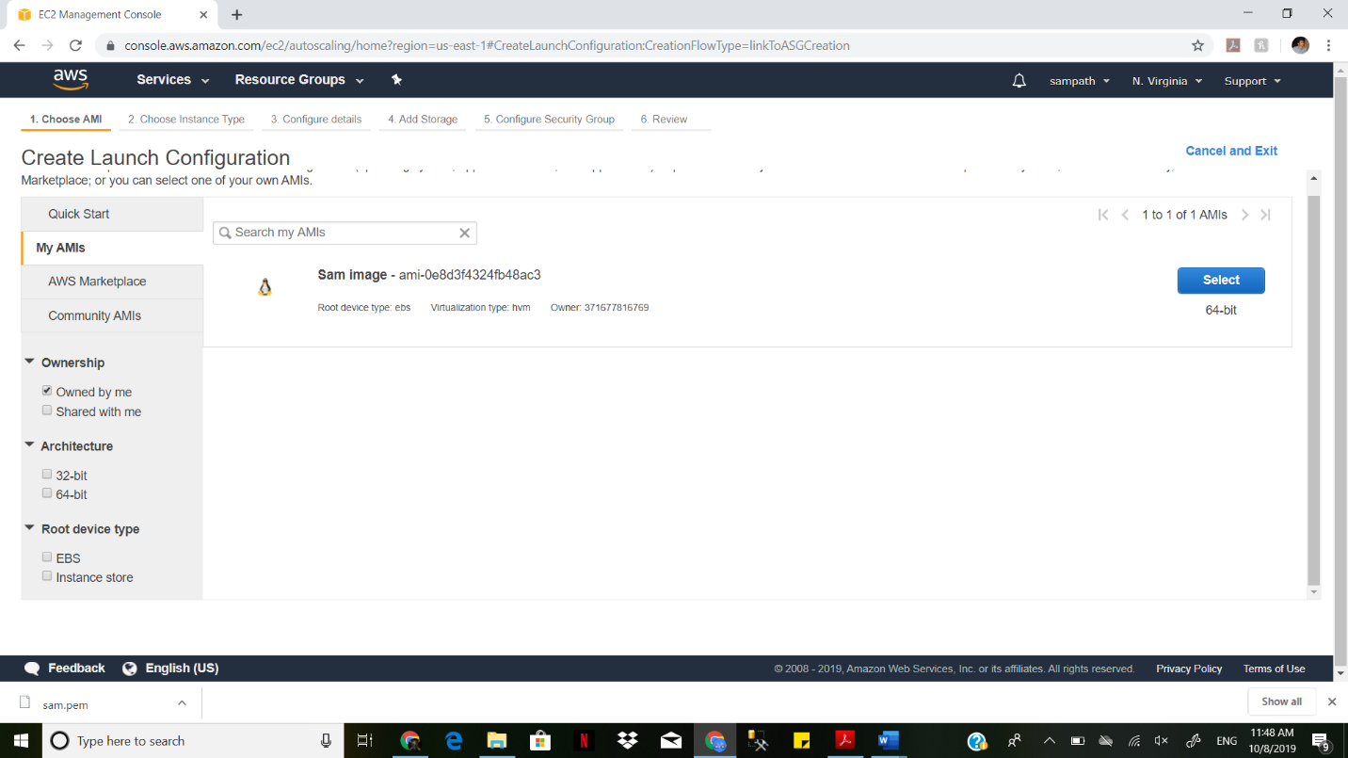

We go to AMI’s and select the image which we created in Instances.

We give a name to that image

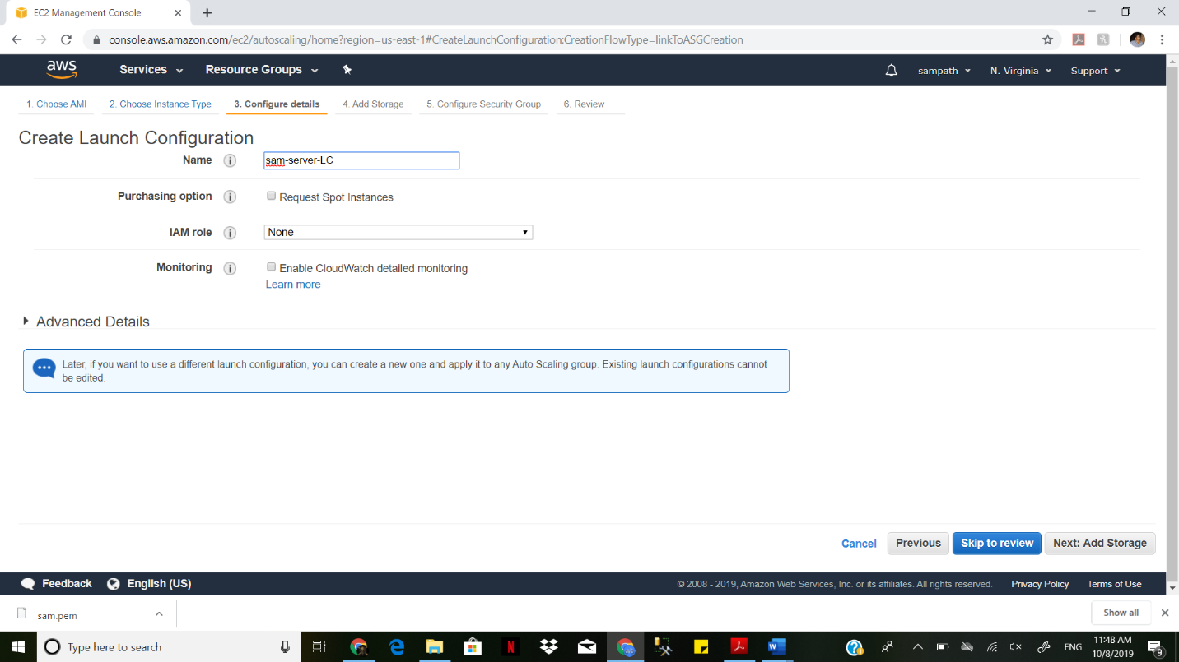

We give a group name to the Image in autoscaling.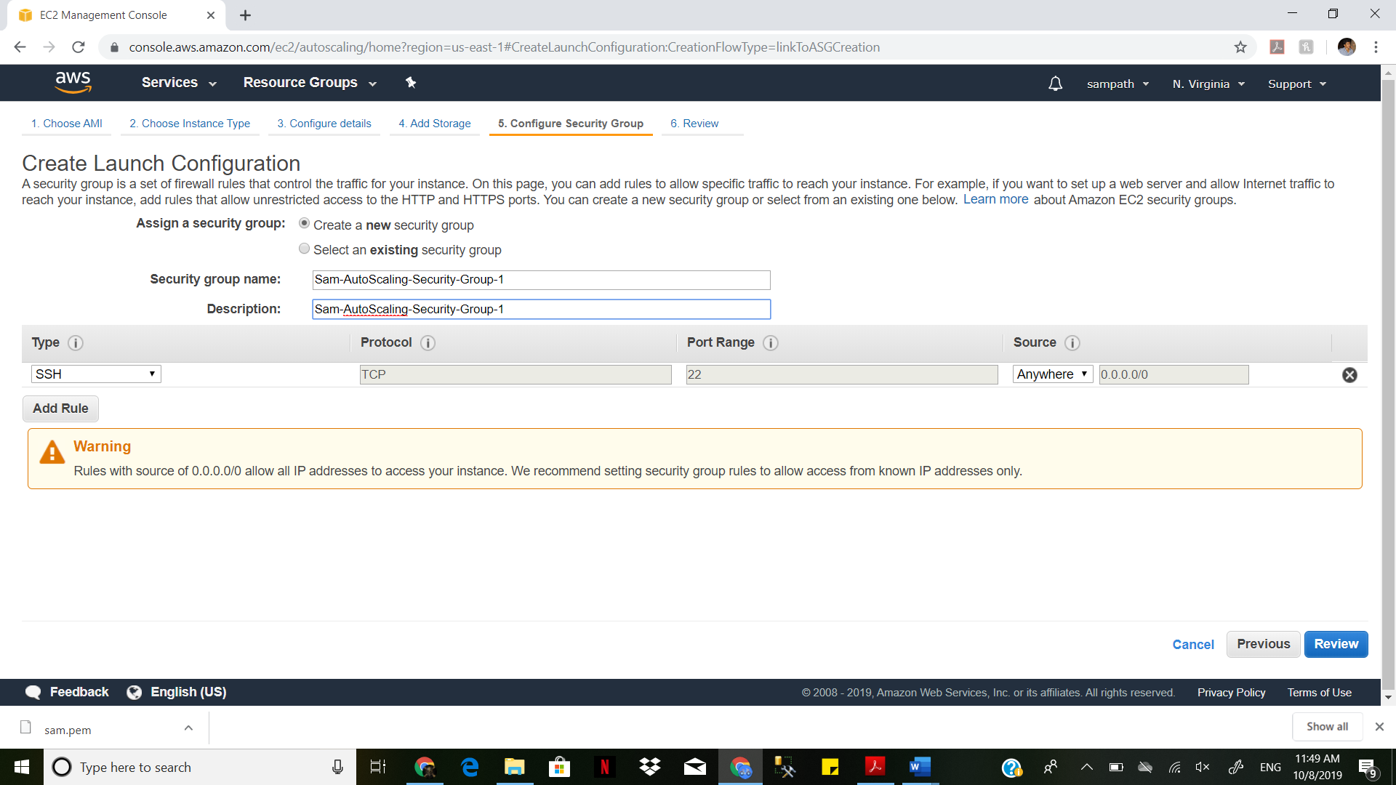

Create Auto Scaling Group

Select group size by starting with 2 instances

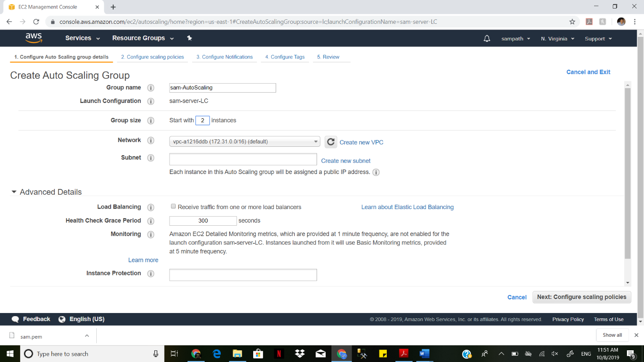

**Select Auto Scaling 4 groups as specified in the HW**

**Select health check for 30 seconds**

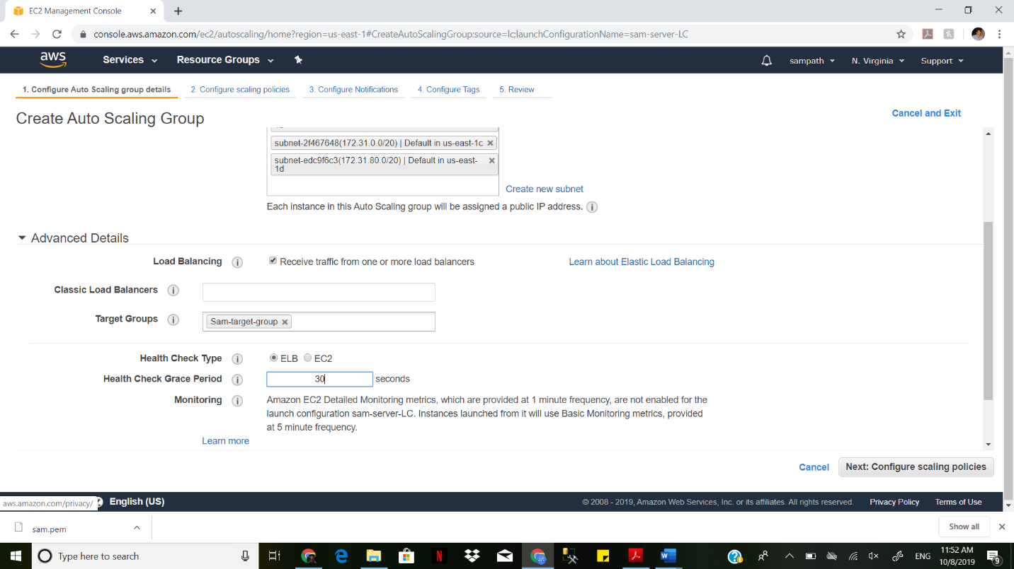

Creating sam-AutoScaling group

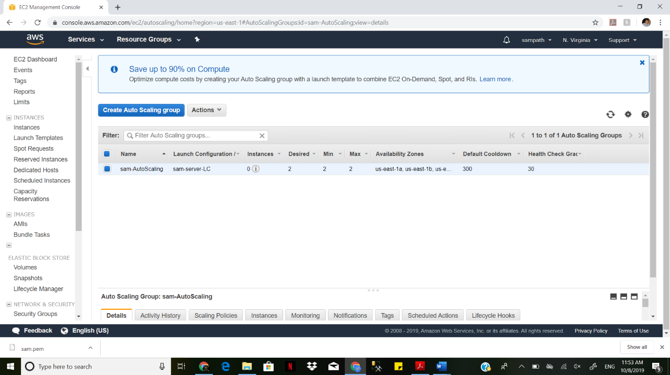

Here is the Review for the things which we created in Auto Scaling.

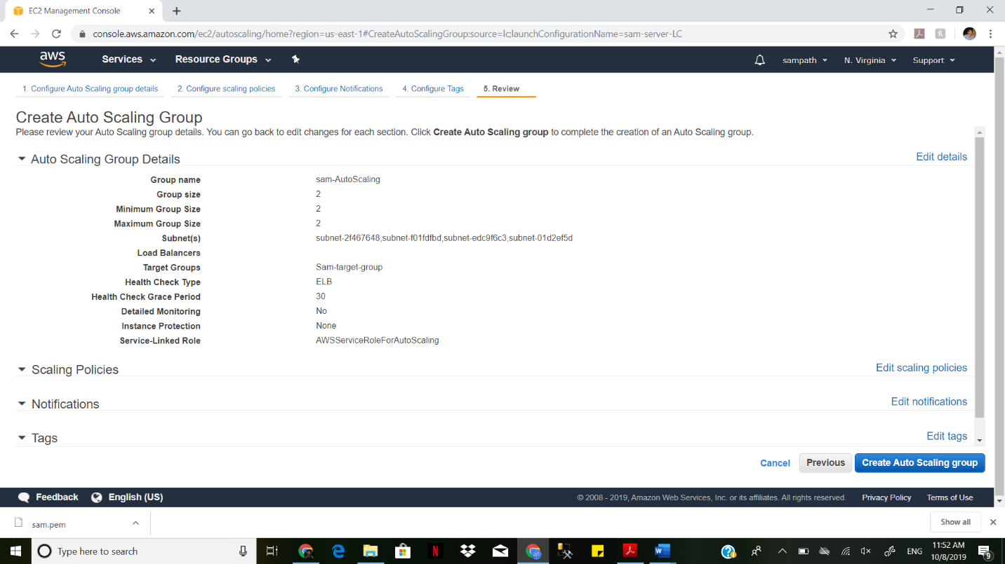

As we specified two instances in Auto Scaling groups it has automatically created two instances

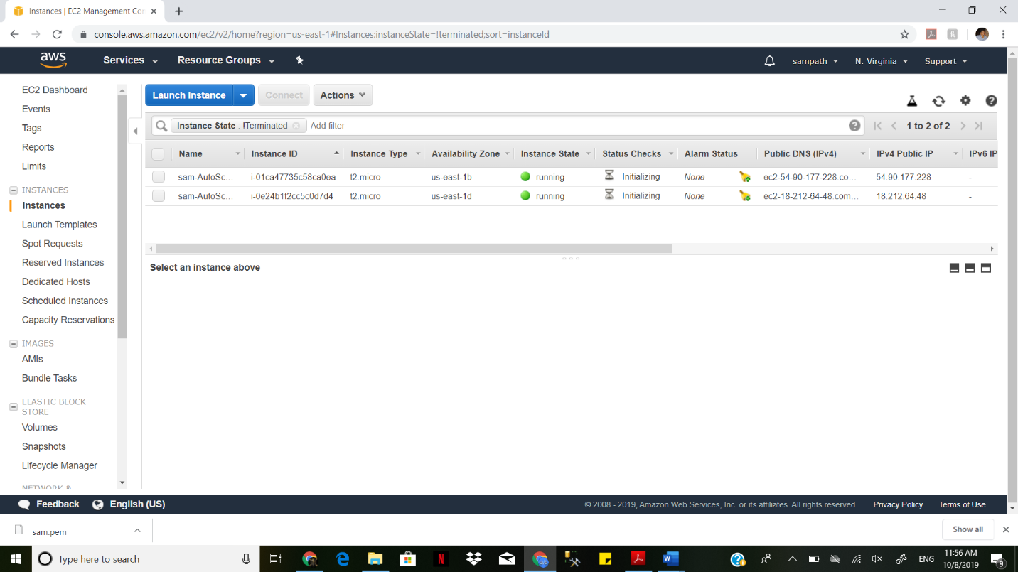

I the status we can clearly see the instances created successfully.

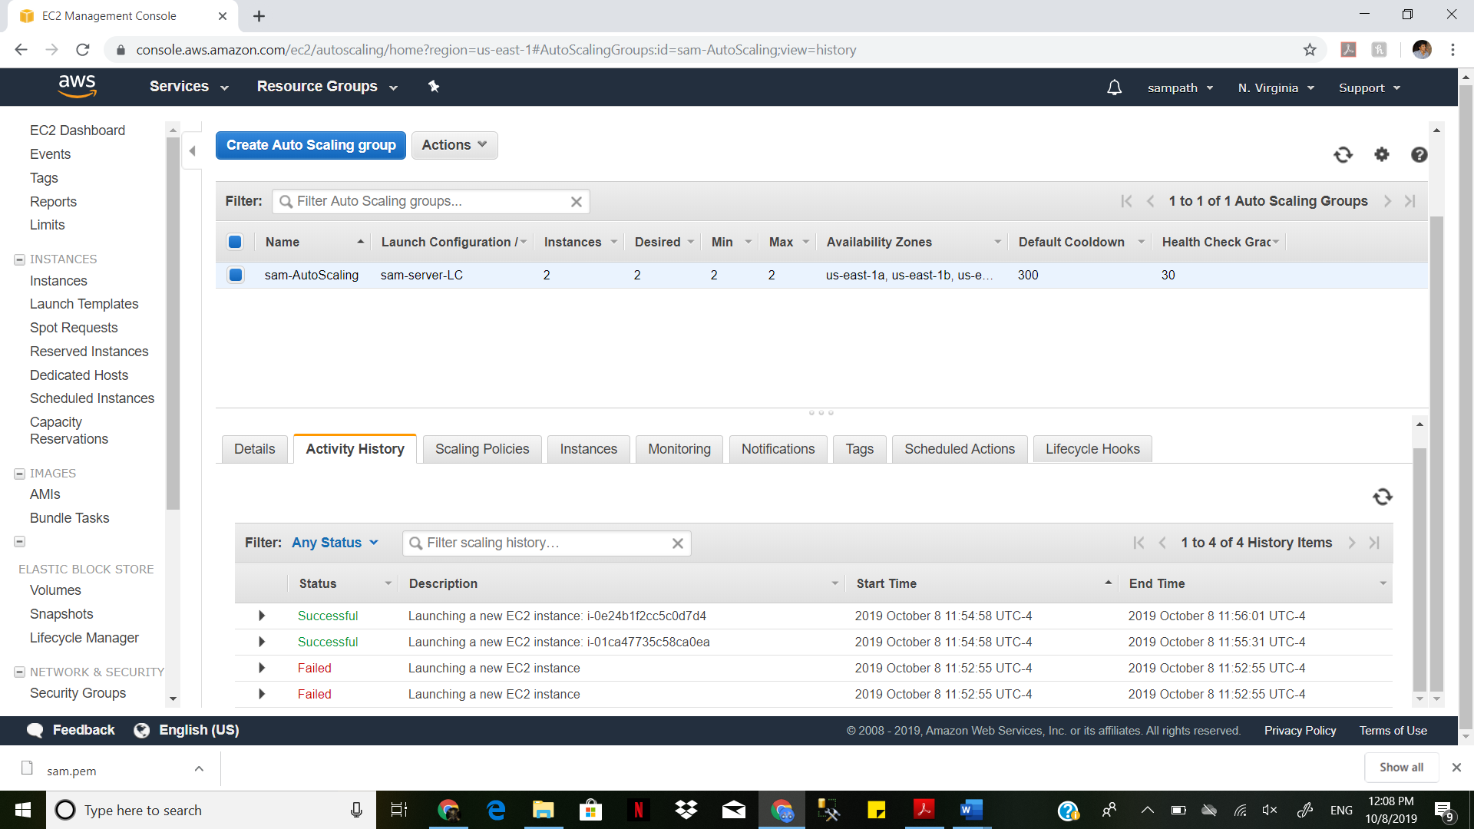

In Target groups we can see the instances selected the subnets.

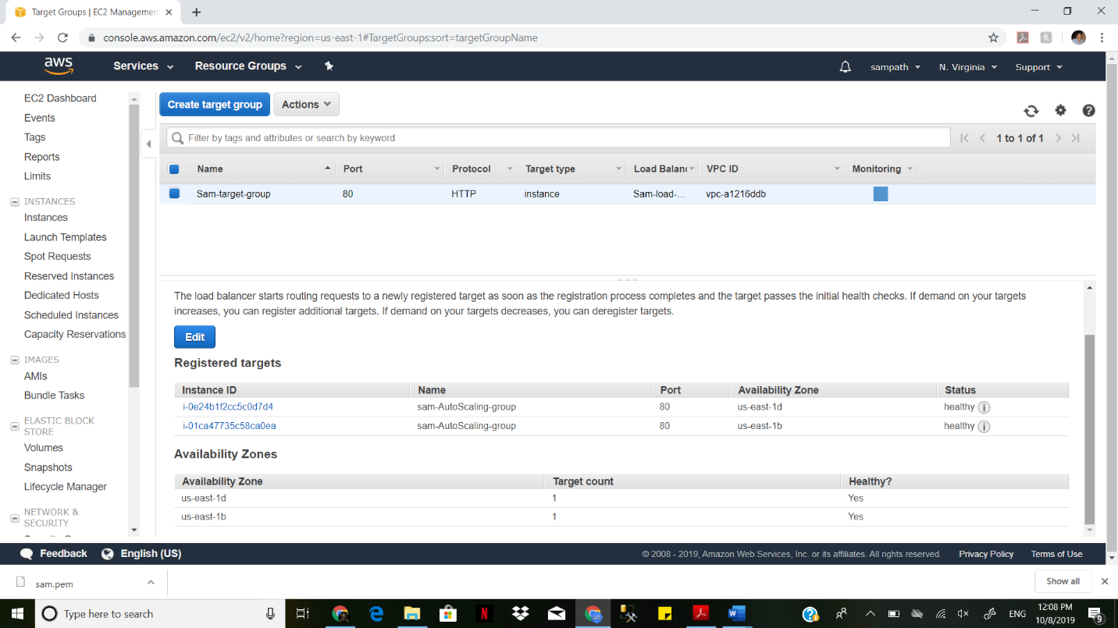

We are deleting one instance.

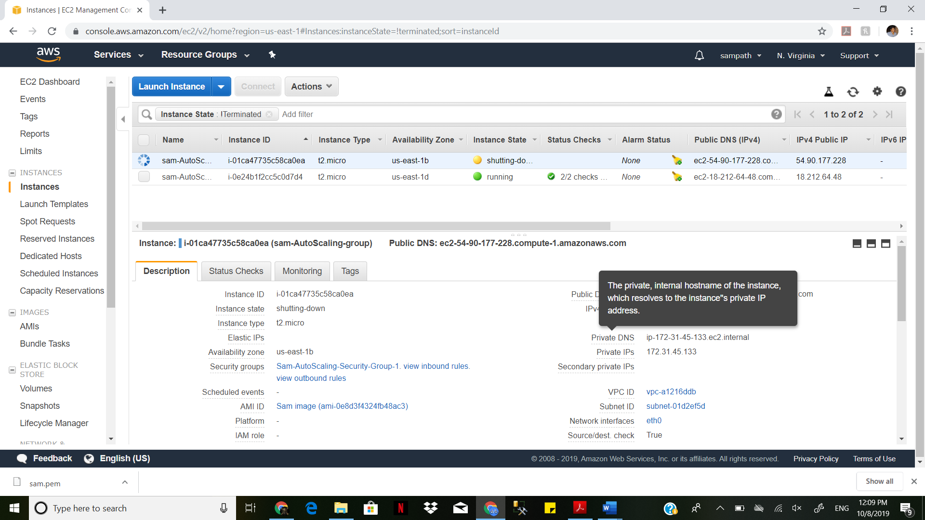

The instance is terminated successfully

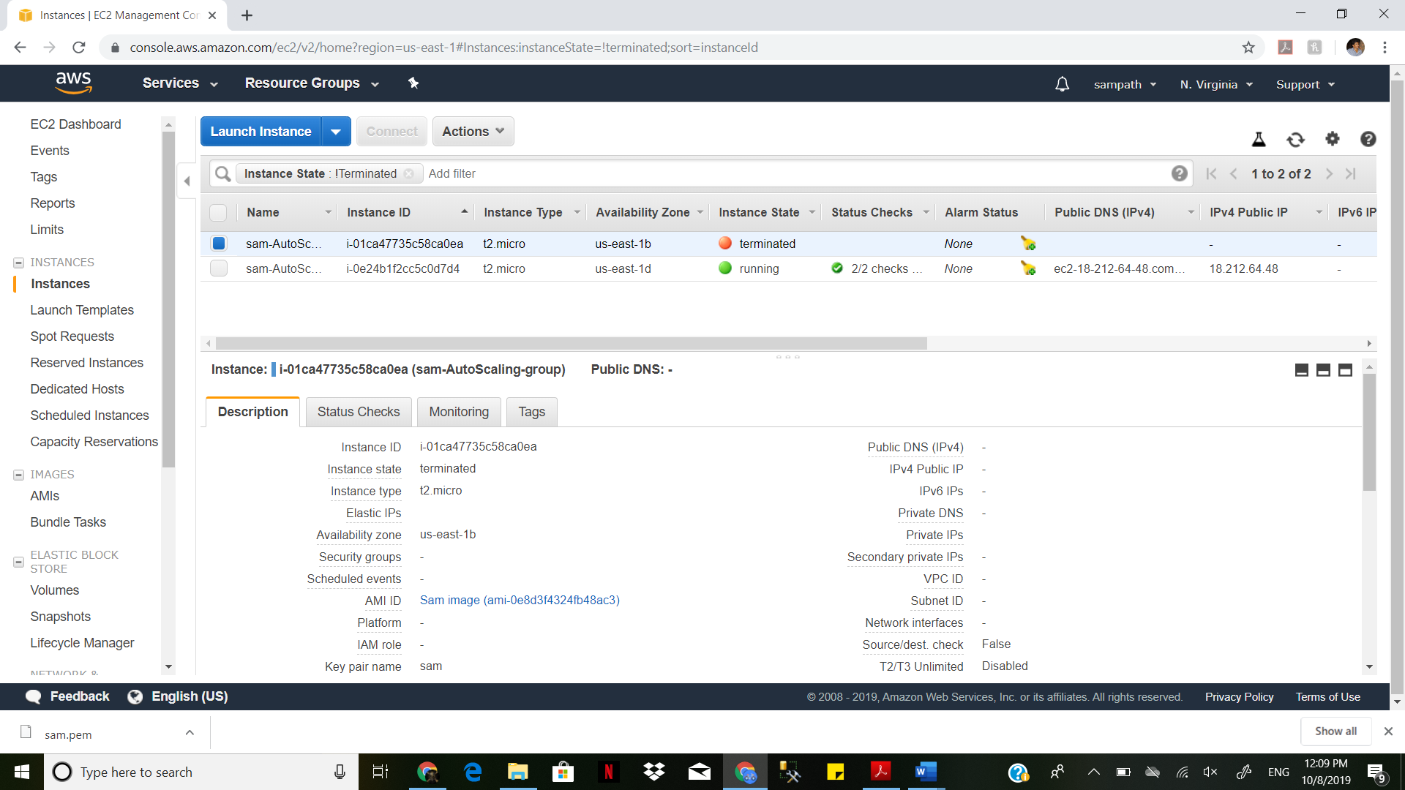

We created the Auto Scaling group with 2 Instances but we deleted one instance.

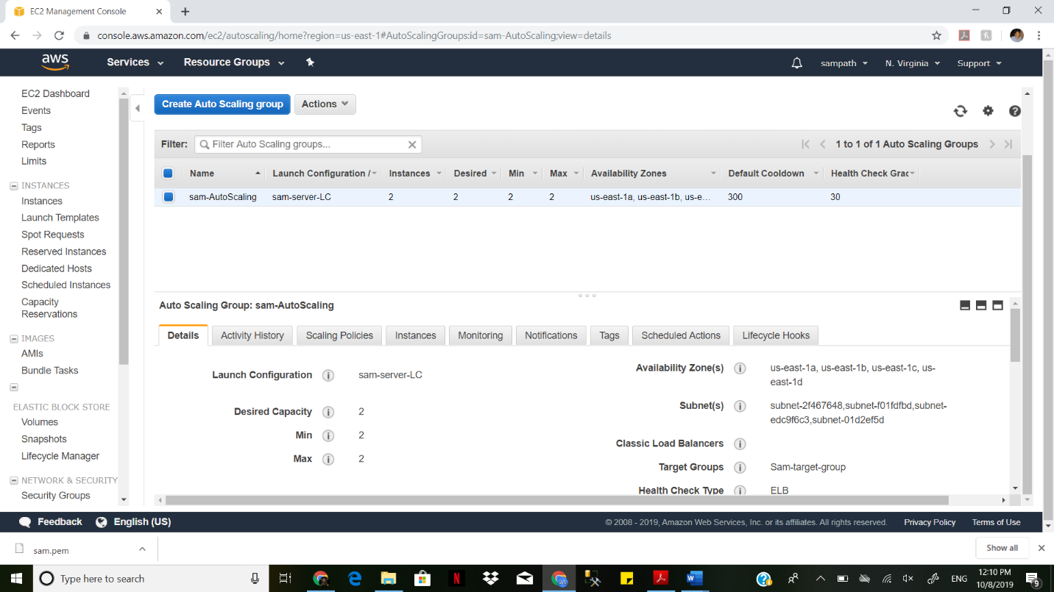

So, the instances we automatically created by the Auto Scaling Groups

We can clearly see it in the status.

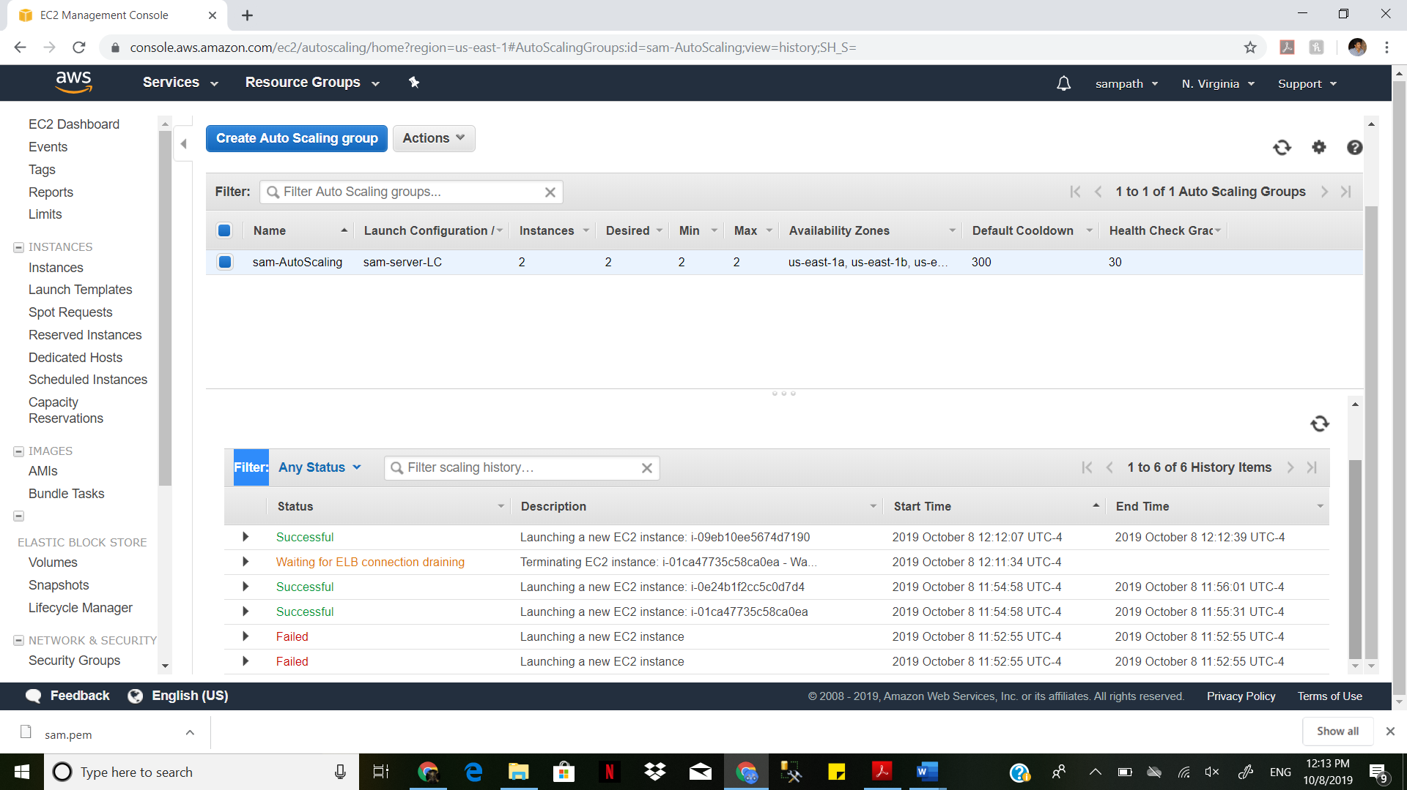

The instance is created automatically with in few minutes

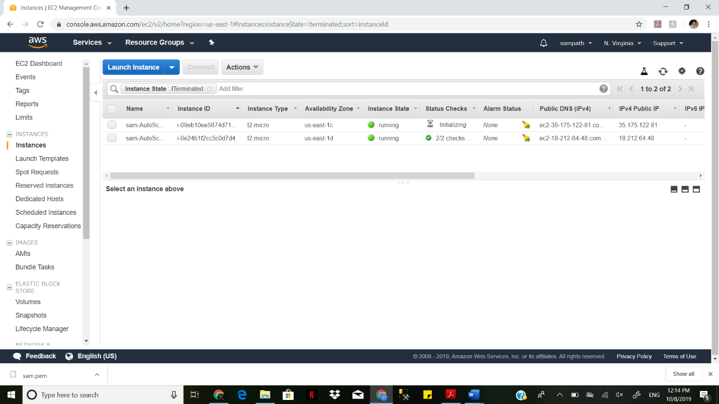

We are now removing all the recourses which we created.

We first delete auto scaling groups.

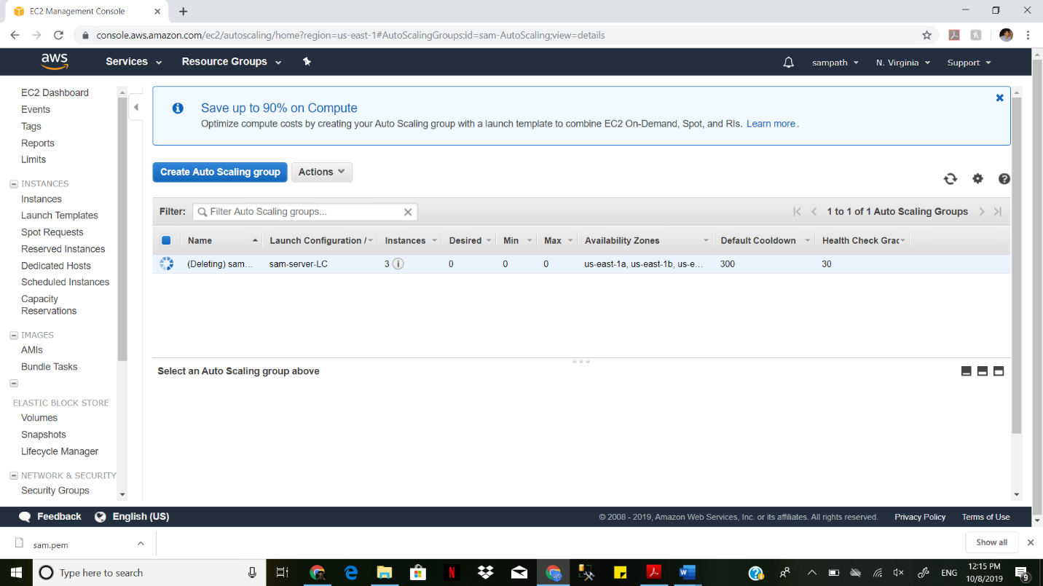

Next deleting launch Configuration.

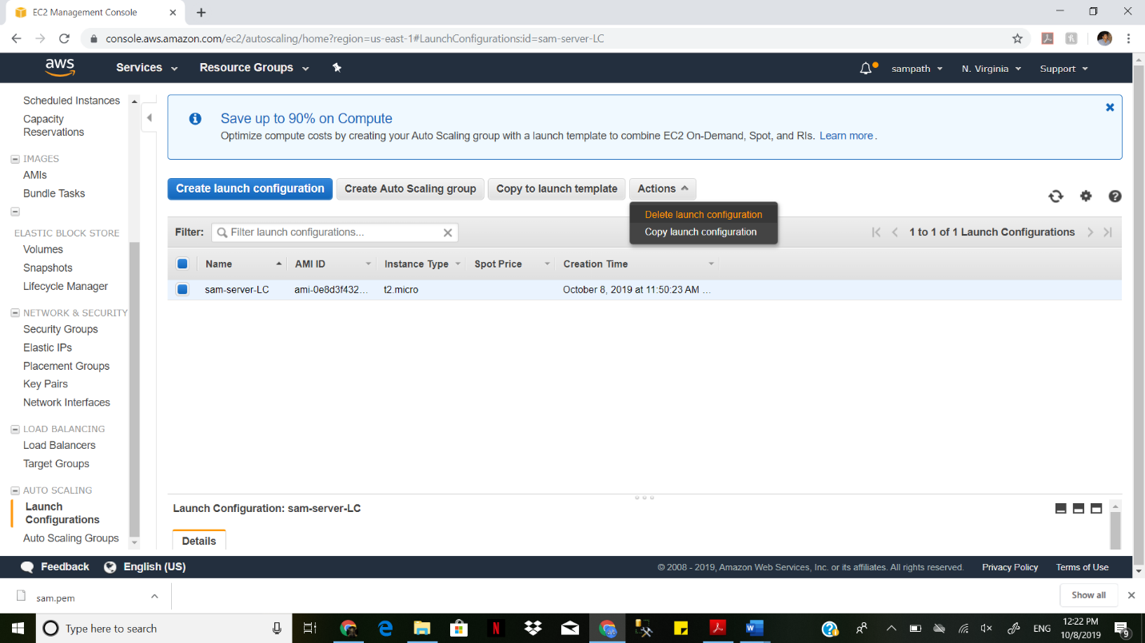

Next Delete Load Balancer

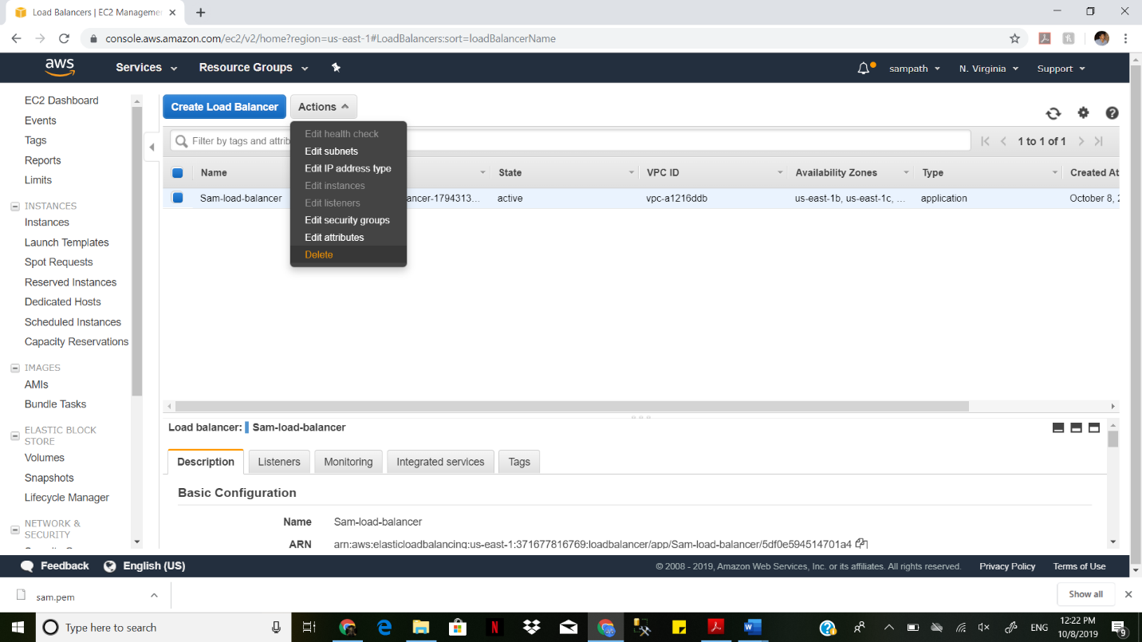

Next Deleting Target groups.

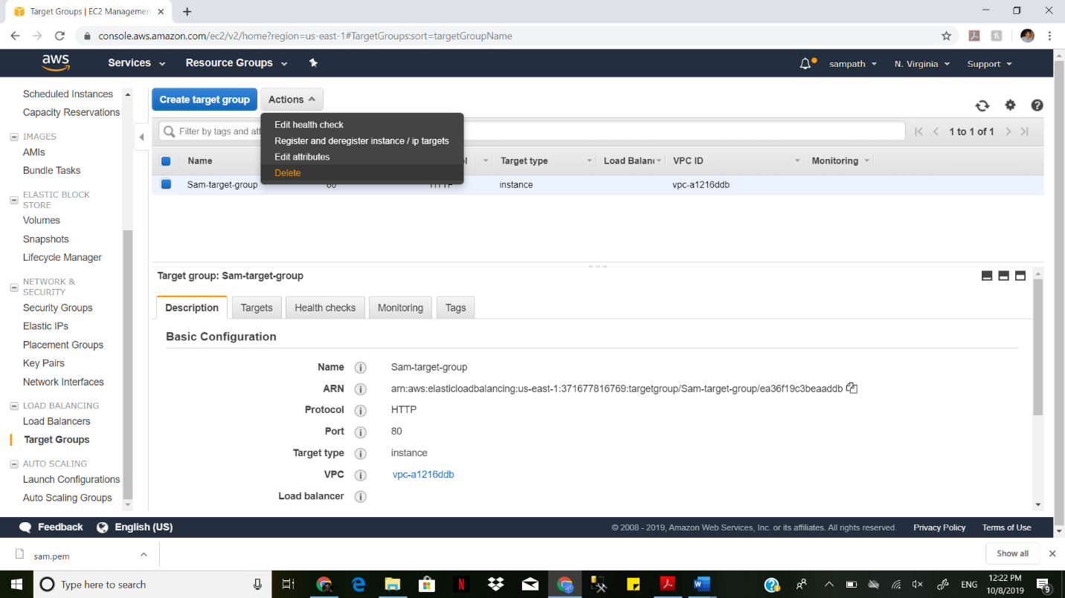

Next delete Snapshots

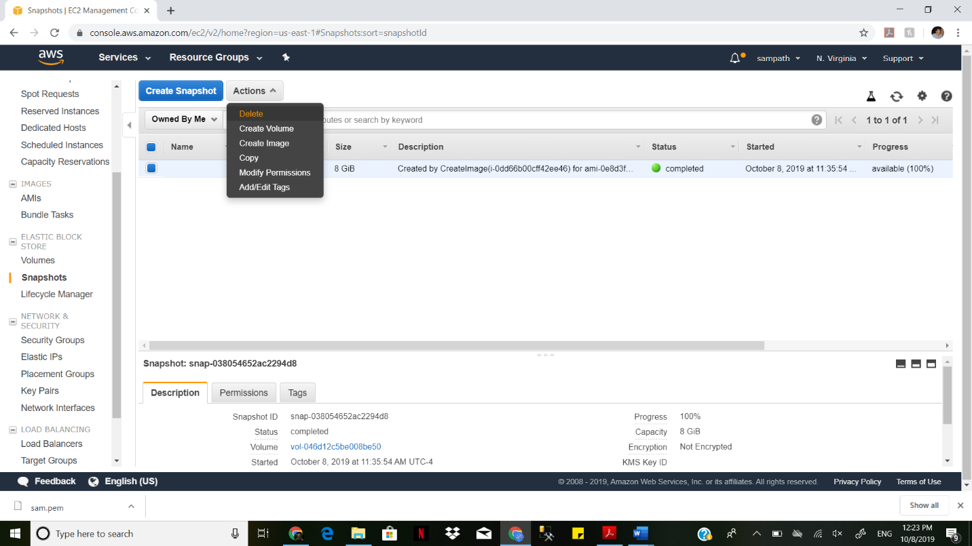

Next Deregister AMIs

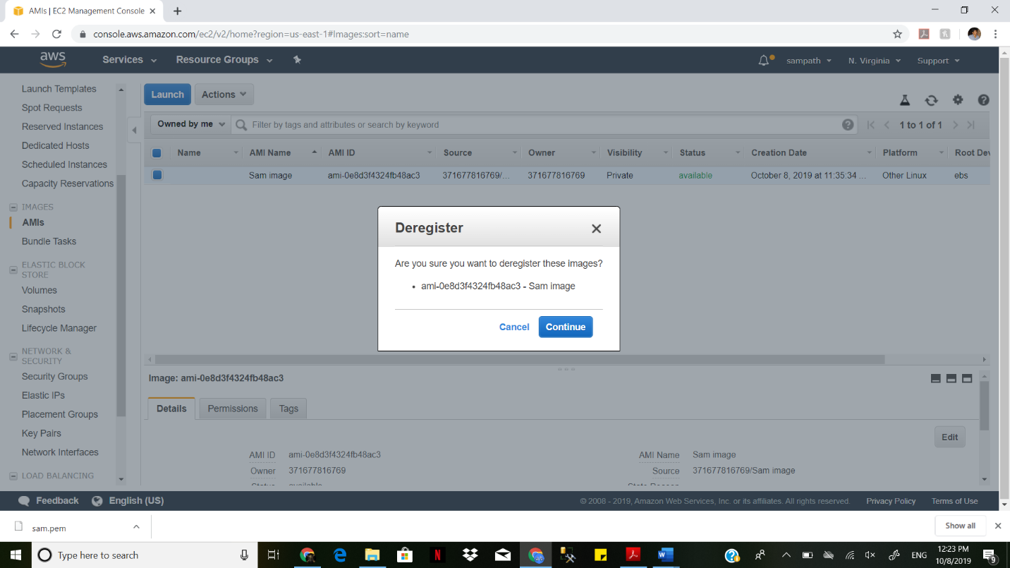

Next delete security groups

